PIZZA SALES SQL QUERIES

**A.KPI’s**

**1. Total Revenue**

SELECT SUM(total_price) AS Total_revenue FROM pizza_sale;

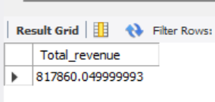

**2. Average order value**

SELECT DISTINCT SUM(total_price) / COUNT(DISTINCT order_id) AS Average_order_value FROM pizza_sale;

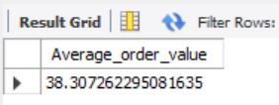

**3. Total Pizzas sold**

SELECT SUM(quantity) AS Total_pizzas_sold FROM pizza_sale;

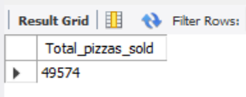

**4. Total orders**

SELECT COUNT(DISTINCT order_id) AS TOTAL_ORDERS FROM pizza_sale;

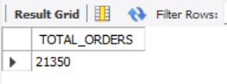

**5.Average pizzas per order**

SELECT SUM(quantity) / COUNT(DISTINCT order_id) AS Average_pizzas_per_order FROM pizza_sale;

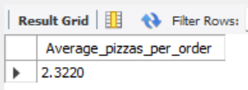

**B. Hourly trend for total pizzas sold**

SELECT HOUR(order_time) AS Order_hour,

SUM(quantity) AS Total_pizas_sold FROM pizza_sale

GROUP BY HOUR(order_time)

ORDER BY HOUR(order_time);

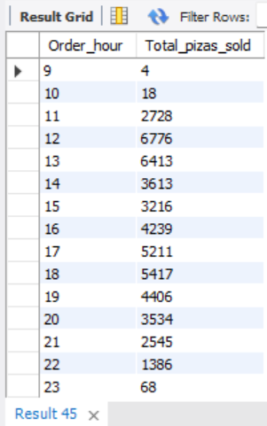

**C. Weekly trend for total orders**

SELECT WEEK(order_date) AS Order_week, YEAR(order_date) ,

COUNT(DISTINCT order_id) AS Total_pizzas_orders FROM pizza_sale

GROUP BY WEEK (order_date),YEAR(order_date)

ORDER BY WEEK (order_date),YEAR(order_date);

|  |  |
| --- | --- |
|  |  |

|  |
| --- |
| **D. Percentage of sales by pizza category**    SELECT pizza_category, SUM(total_price) AS Total_sales, SUM(total_price)*100 / (SELECT SUM(total_price) FROM pizza_sale  WHERE MONTH(order_date) = 1) AS Percentage_of_total_sales FROM pizza_sale  WHERE MONTH(order_date) = 1  GROUP BY pizza_category;    **E.** **Percentage of sales by pizza size**  SELECT pizza_size, cast(SUM(total_price) AS DECIMAL(10,2)) AS Total_sales,  CAST(SUM(total_price)*100 / (SELECT SUM(total_price) FROM pizza_sale  WHERE QUARTER(order_date) = 1) AS DECIMAL (10,2)) AS Percentage_of_total_sales  FROM pizza_sale  WHERE QUARTER(order_date) = 1  GROUP BY pizza_size  ORDER BY Percentage_of_total_sales DESC;    **F. Top 5 Pizzas by Revenue**  SELECT pizza_name, SUM(total_price) AS Total_Revenue FROM pizza_sale  GROUP BY pizza_name  ORDER BY SUM(total_price) DESC  LIMIT 5;    **G. Bottom 5 Pizzas by Revenue**  SELECT pizza_name, ROUND(SUM(total_price)) AS Total_Revenue FROM pizza_sale  GROUP BY pizza_name  ORDER BY SUM(total_price)  LIMIT 5;    **H. Top 5 Pizzas by Quantity**  SELECT pizza_name, SUM(quantity) AS Total_Quantity FROM pizza_sale  GROUP BY pizza_name  ORDER BY SUM(quantity) DESC  LIMIT 5;    **I. Bottom 5 Pizzas by Quantity**  SELECT pizza_name, SUM(quantity) AS Total_Quantity FROM pizza_sale  GROUP BY pizza_name  ORDER BY SUM(quantity)  LIMIT 5; |